**Project Documentation**

* **Objective of The Project**
  + Task Management Get Easy.
  + Listing Out the Prioritized Task.
  + User Friendly UI.
  + Easily Updating the Task**.**
* **Users of The Project**
  + Business Man
  + Students
  + Common Peoples
* **Events in The Project**
* Creating the Task.
* Update the Task.
* Deletion of the Task.
* Listing Out Prioritized Task.
* **List of The Forms** 
  + **1)Add Task (Popup)**

-In this form When user click on the add Task Button the Model Will Pop up Like This.



Task Name

Description

Date

Add Task

* **2) All Task (On Cards)**

-When Task is added Form the User That will Listed Out Here In the Card Format.

Update

Update

Update

Delete

Delete

Delete

Prioritize

Prioritize

Prioritize

Update

Update

Update

Delete

Delete

Delete

Prioritize

Prioritize

Prioritize

* **3) Prioritized Task (On Cards)**

**-**When User Click On the Prioritized Button then that Task will Transferred to the Prioritized Task Section.

Delete

Delete

Delete

Delete

Delete

Delete

* **Reports**

1. **All Task (On Cards)**

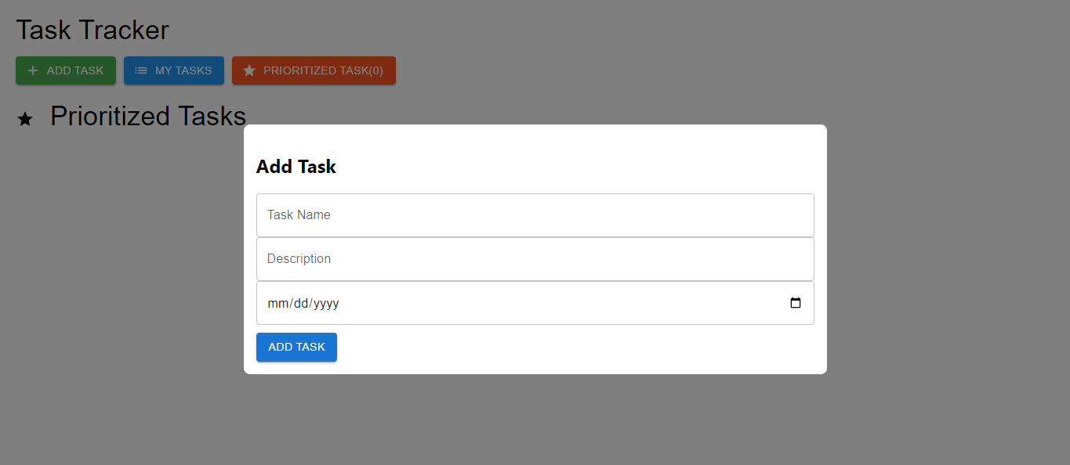

1. **All Task (On Cards)**

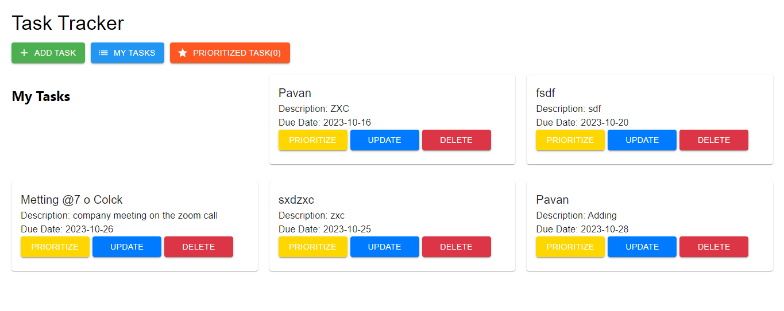

1. **Prioritized Task (On Cards)**

